Unit 4.7 – Market for Loanable Funds Questions

- Which of the following will most likely result in a lower real interest rate in a nation?
- The nation provides an investment tax credit to new businesses.
- The citizens of the nation increase their savings for retirement.
- The nation is experiencing political instability and economic risk.
- The nation’s central bank sells government bonds in the open market.
- The nation’s government increases its borrowing to finance spending on capital projects.
- Which of the following changes in the loanable funds market will decrease the equilibrium real interest rate?
- A decrease in private savings
- A decrease in the expected inflation rate
- An increase in government spending on highways financed by borrowing
- An increase in foreign financial capital inflows
- An investment tax credit for plant and equipment
- If the loanable funds market is in equilibrium, then which of the following must be true?
- Government spending equals tax revenues.
- Investment spending equals national savings.
- Investment spending equals private savings.
- Borrowing equals lending.
- Foreign inflows of financial capital equal investment spending.
- If investors feel that business conditions will deteriorate in the future, the demand for loans and real interest rate in the loanable funds market will change in which of the following ways in the short run?
 | Demand for Loans | Real Interest Rate
A | Increase | Increase
B | Increase | Decrease
C | Decrease | Increase
D | Decrease | Decrease
E | Decrease | Not Change

- An increase in the demand for loanable funds could be best explained by which of the following?
- There is a decrease in investment spending.
- There is an increase in the government’s budget surplus.
- Firms are optimistic about the future performance of the country’s economy.
- Domestic investors seek higher returns by investing in foreign financial assets.
- The economy is facing political instability.
- In the short run, government deficit spending will most likely
- raise the unemployment rate
- lower the inflation rate
- raise nominal interest rates
- lower private savings
- raise net exports
- Which of the following will cause an increase in the equilibrium real interest rate?
- An increase in investment demand
- An increase in national saving
- An increase in the government budget surplus
- A decrease in the government budget deficit
- The purchase of government bonds by the central bank
- Which of the following will increase the supply of loanable funds?
- An increase in household saving
- An increase in open market sales by the central bank
- An increase in government spending
- An increase in transfer payments
- An increase in investment demand

- Interest rates are important in explaining economic activity.
- Using a correctly labeled graph of the money market, show how an increase in the income level will affect the nominal interest rate in the short run.
- Using a correctly labeled graph of the loanable funds market, show how a decision by households to increase saving for retirement will affect the real market interest rate in the short run.
- Suppose that the nominal interest rate has been 6 percent with no expected inflation. If inflation is now expected to be 2 percent, determine the value of each of the following.
- The new nominal interest rate
- The new real interest rate
- The government replaces the income tax with a national sales tax that generates the same revenue. Assume throughout the question that the economy stays at full employment.
- What is the effect of the change in tax policy on each of the following?
- Consumption
- National saving
- Using a correctly labeled graph of the loanable-funds market, explain how the change in tax policy will affect each of the following.
- Real interest rate
- Investment
- Explain how this change in policy will affect long-run economic growth.

- Springland Bank is a commercial bank in Ansonia with the following balance sheet (T-account).
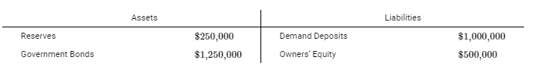
(a) Calculate the required reserve ratio if Springland Bank holds no excess reserves. Show your work.
(b) The central bank of Ansonia buys $10,000 of government bonds from Springland Bank. What is the dollar value of the change in the monetary base? Explain using numbers.
(c) Based on your answer to part (a), calculate the maximum change in the money supply as a result of the central bank bond purchase after all adjustments take place in the banking system. Show your work.
(d) Given the change in the money supply in part (c), calculate the velocity of money if nominal gross domestic product changes by $240,000. Show your work.
(e) Assume the economy of Ansonia is initially at full employment. Based solely on the change in the money supply in part (c), will real output increase, decrease, or stay the same in the short run? Explain.

- Suppose that the United States government implements a fiscal policy that increases the budget surplus.
(a) Draw a correctly labeled graph of the loanable funds market and show the effect of the increase in the budget surplus on the equilibrium real interest rate.
(b) The European Union is a major trading partner of the United States. Given your answer in part (a) about the real interest rate, will the United States dollar appreciate or depreciate against the euro? Explain.
(c) Suppose that the Federal Reserve, the central bank of the United States, decides to offset the change in the value of the dollar identified in part (b).
(i) Would the Federal Reserve buy or sell the euro?
(ii) Would the Federal Reserve buy or sell the dollar?
(d) Suppose that the Federal Reserve wants to counteract the real interest rate change identified in part (a). What open-market operation would the Federal Reserve use?
- Include correctly labeled diagrams, if useful or required, in explaining your answers. A correctly labeled diagram must have all axes and curves clearly labeled and must show directional changes. If the question prompts you to “Calculate,” you must show how you arrived at your final answer.
The loanable funds market in Country Z is in equilibrium.
(a) Draw a correctly labeled graph of the loanable funds market showing the equilibrium real interest rate and the equilibrium quantity of loanable funds.
(b) Assume household savings in Country Z increases.
(i) Will this cause a shortage or a surplus in the loanable funds market at the current equilibrium real interest rate?
(ii) On your graph in part (a), show the effect of the increase in household savings on the equilibrium real interest rate.
(c) Based on your answer to part (b)(ii), will lenders be better off or worse off?
(d) Based on your answer to part (b)(ii), what will happen to investment spending in Country Z? Explain.

- A national newspaper’s headline reads “Business Confidence Reaches Highest Level in 5 Years.”
(a) Draw a correctly labeled graph of the loanable funds market, and show the effect of high business
confidence on the equilibrium real interest rate.
(b) Assume the government increases its spending on capital projects and infrastructure. Would
financing the increased government spending by borrowing result in a higher, a lower, or the same
equilibrium real interest rate? Explain.
(c) How will the increase in government spending financed by borrowing affect national savings?
(d) If the expected inflation rate decreases to zero, will the nominal interest rate be greater than, less
than, or equal to the real interest rate? Explain

Answers

1 b

2 d

3 d

4 d

5 c

6 c

7 a

8 a

10 fr
a
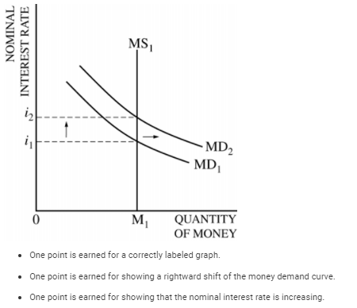
b
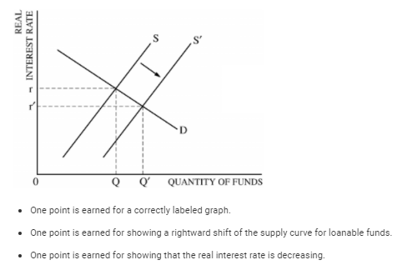
c
One point is earned for indicating that the nominal interest rate is 8 percent.
One point is earned for indicating that the real interest rate is 6 percent.

11 fr
a
1 point: consumption decreases
1 point: national savings increases
b
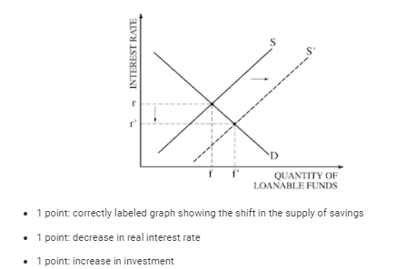
c
1 point: long-run growth will increase
1 point: linking growth to changes in productivity and capital stock

12 fr
a
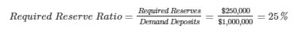
b
The response states that the monetary base will increase by $10,000 and explains that the central bank bond purchase increases reserves by $10,000 and the monetary base is the sum of reserves and currency in circulation.
c
d
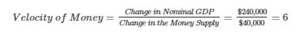
e
The response states that real output will increase in the short run and explains that the increase in the money supply will decrease the nominal interest rate, which will increase interest-sensitive spending and increase aggregate demand.

13 fr
a
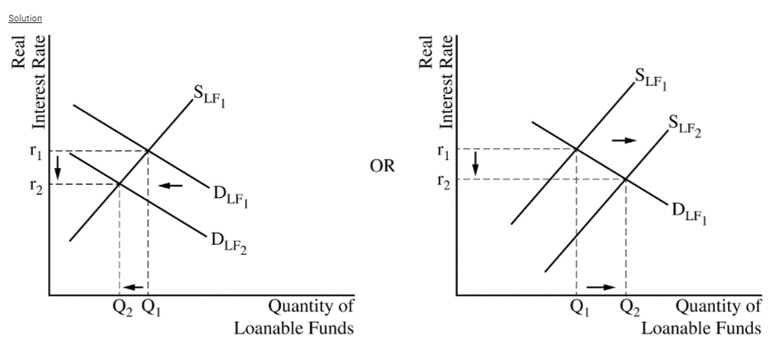
b
The response states that the dollar will depreciate against the euro and explains that the demand for United States financial assets decreases which decreases the demand for the dollar or increases the supply of the dollar. (It is also acceptable to explain that as investors seek higher returns in foreign financial assets, there will be financial capital outflows, which decreases the demand for the dollar or increases the supply of the dollar.)
c
The response states that the Federal Reserve should sell the euro and buy the dollar.
d
The response states that the Federal Reserve should sell bonds.

14 fr
a
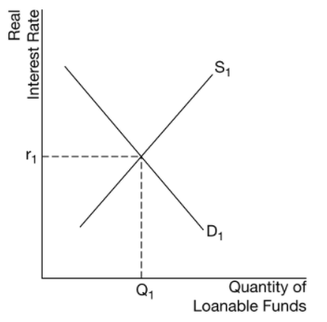
b
There will be a surplus.
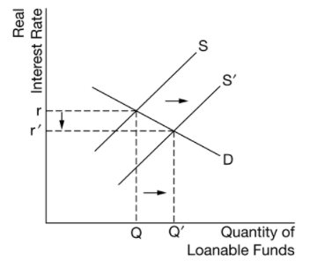
c
The response states that lenders will be worse off.
d
The response states that investment spending will increase and explains that a decrease in real interest rates reduces the cost of borrowing, which increases investment spending.

15 fr
- Demand for loanable funds will increase which will increase the equilibrium RIR.
- Also increase demand which will increase the RIR.
- National savings will decrease because the government is borrowing and therefore saving less.
- RIR = NIR – Infl, If inflation = 0 then RIR = NIR

